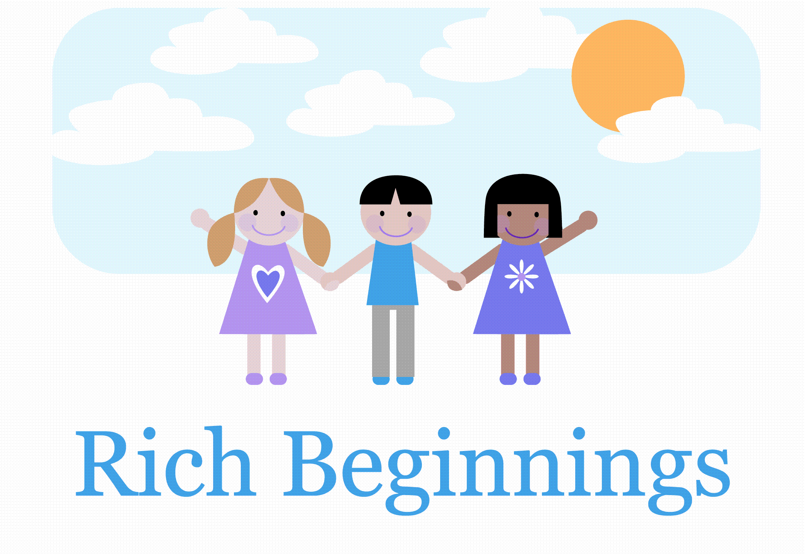
Welcome to the Toddler Room!
Our goal in the Toddler Room is to provide a safe environment for toddlers that will challenge their emerging skills. We will teach a sense of self, especially as separate from others, and work to build self-esteem through a variety of positive experiences!
Your child will be cared for by their primary caregiver, with the Lead Teacher overseeing daily operations. Primary care means, their assigned teacher will be in charge of changing your child’s diaper, monitoring their lunch and is with them when small groups are formed for activity. Through the assignment of a primary caregiver, your toddler will continue to form secure attachments and learn to trust the adults around them.
Monthly you will receive a themed activity calendar which includes, fun projects, small and large motor skill themed activities, as well as cultural and social awareness and diversity. Be sure to check the bulletin board outside the classroom for important information and updates, our daily sheet, and calendar.
We as a team will provide daily exposure to books, songs and finger-plays to encourage language development as well positive encouragement to use their words. Also, your child’s teachers will model reflective language for vocabulary development. A wide variety of different mediums will be used to learn colors, shapes, numbers and textures daily. Each child will have an opportunity to explore and play freely with little restrictions placed on them in a safe environment. Your child will have ample opportunities for independent play and to join in on group activity as well.
To encourage large motor skills, age-appropriate play equipment is provided inside and outside daily. Your child will have playground time, trail exploration and courtyard fun. We understand that children need opportunities to do things that are exciting and adventurous. Activities will challenge your child’s physical, social and cognitive abilities and foster growth in each area. Play-doh, bead-travelers, latch boards, and other fine motor skill mediums are offered daily through free play and teacher directed activity.
Each November and May you will receive a written observation on your child’s growth and development with an opportunity to schedule a parent-teacher conference. We are always available to meet with you at any time.
Attached is the daily schedule which outlines our typical day in the Toddler Room, a supply list of items that your child will need, and other important Toddler Room information.
We look forward to a successful year for you and your child. If you have any questions or concerns please feel free to talk with us.

